Assignment 11: Deploy mini-project on Google App Engine

1. GitHub Repository

Step 1: Create Project Folder

Step 2: Create Files

Step 3: Initialize Git

Step 4: Push to GitHub

Step 5: Copy Repo Link

https://github.com/YOUR_USERNAME/library-gae

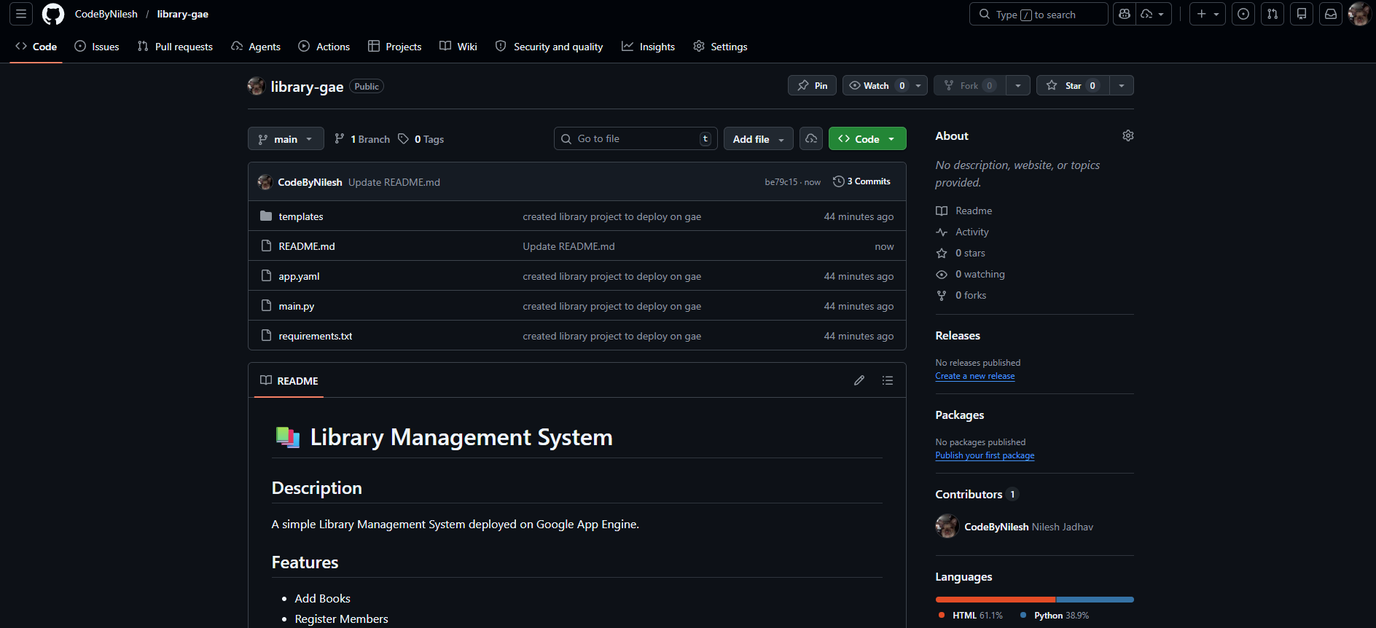

2. Google App Engine

1. Go to: https://console.cloud.google.com

2. Select your project

3. Click "Activate Cloud Shell"

4. Clone your repo:
git clone https://github.com/YOUR_USERNAME/YOUR_REPO.git

5. Navigate to folder:
cd YOUR_REPO

6. Create app.yaml:
echo "runtime: python39" > app.yaml

7. Deploy:
gcloud app deploy

8. Open app:
gcloud app browse

9. Your app loads at:
https://YOUR-PROJECT-ID.uc.r.appspot.com

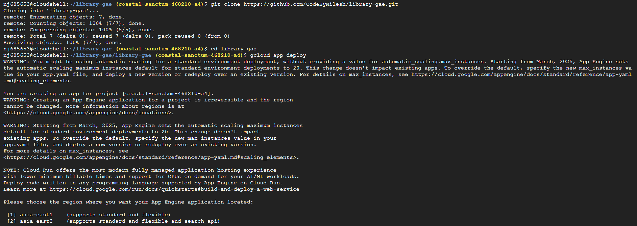

3. Live Demo

